Offene Fragen
„Hardware“
Bitte beschreiben Sie jeweils in eigenen Worten und mit Hilfe der Wortwolke die Aufgaben der jeweiligen Hardwarebestandteile eines Computers:

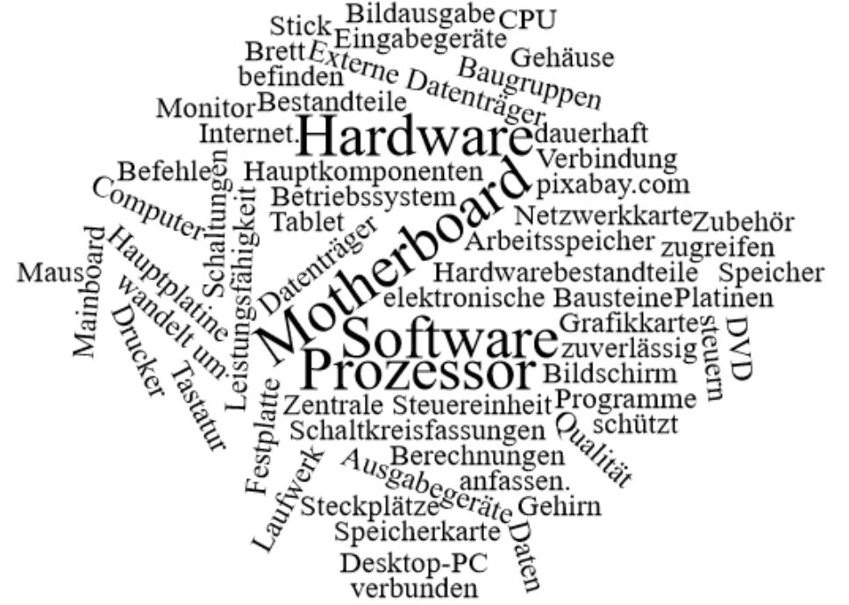
- Gehäuse
__________________________________________________________________________________________________________________________________________
- Hauptplatine (Motherboard)
__________________________________________________________________________________________________________________________________________
_____________________________________________________________________
__________________________________________________________________________________________________________________________________________
_____________________________________________________________________
- Prozessor
_____________________________________________________________________
__________________________________________________________________________________________________________________________________________
_____________________________________________________________________
_____________________________________________________________________
- Arbeitsspeicher _____________________________________________________________________
__________________________________________________________________________________________________________________________________________
_____________________________________________________________________
- Festplatte
_____________________________________________________________________
__________________________________________________________________________________________________________________________________________
_____________________________________________________________________
- Grafikkarte
_____________________________________________________________________
__________________________________________________________________________________________________________________________________________
_____________________________________________________________________
- Netzwerkkarte
_____________________________________________________________________
__________________________________________________________________________________________________________________________________________
_____________________________________________________________________

