Offene Aufgabe: Internetrecherche Teil 2 - Suchstrategien
Bitte bearbeiten Sie anhand der Wortwolke Fragen zu Suchstrategien und den einzelnen Suchoperatoren.
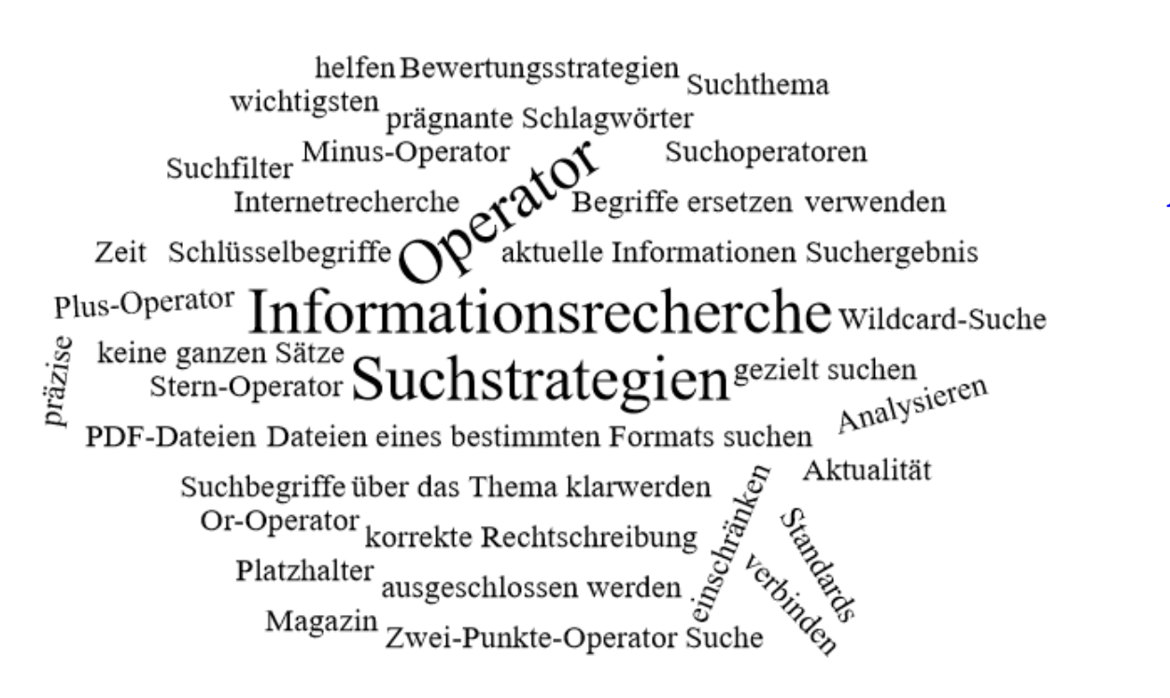

- Nennen Sie 5 wichtige Suchstrategien und begründen Sie deren Bedeutung.
________________________________________________________________________________________________________________________________________________________________________________________________________________________________________________________________________________________________________________________________________________________________________________________________________________________________________________________________________
________________________________________________________________________________________________________________________________________________________________________________________________________________________________________________________________________________________________________________________________________________________________________________________________________________________________________________________________________
____________________________________________________________________________________________________________________________________________________________________________________________________________________________________
- Nennen Sie die 5 wichtigsten Suchoperatoren und geben Sie jeweils ein Beispiel für ihre Anwendung.
________________________________________________________________________________________________________________________________________________________________________________________________________________________________________________________________________________________________________________________________________________________________________________________________________________________________________________________________________________________________________________________________________________________________________________________________________________________________
________________________________________________________________________________________________________________________________________________________________________________________________________________________________________________________________________________________________________________________________________________________________________________________________________________________________________________________________________
________________________________________________________________________________________________________________________________________________________________________________________________________________________________________________________________________________________________________________________________________________________________________________________________________________________________________________________________________
________________________________________________________________________________________________________________________________________________________________________________________________________________________________________________________________________________________________________________________________________________________________________________________________________________________________________________________________________
________________________________________________________________________________________________________________________________________________________________________________________________________________________________________________________________________________________________________________________________________________________________________________________________________________________________________________________________________

