Offene Aufgabe: Tablet starten
Bitte beschreiben Sie folgende Inhalte mit eigenen Worten:
1. Den Startvorgang des Tablets
2. Die Speichermöglichkeiten
3. Die Aufgabe des Windows-Explorer
Nehmen Sie dabei die Wortwolke und die Abbildungen zur Hilfe.
______________________________________________
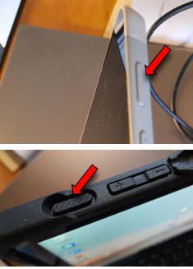
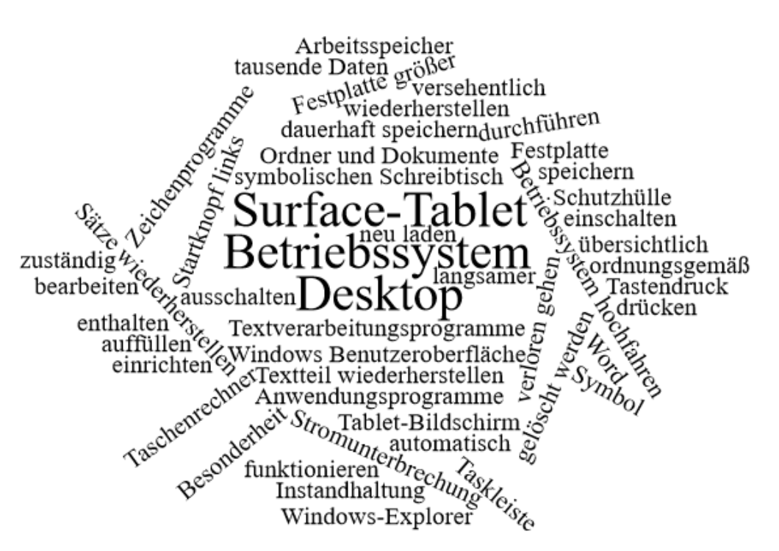
_______________________________________________________
_______________________________________________________
_______________________________________________________
_______________________________________________________
_______________________________________________________
_______________________________________________________
_______________________________________________________
_______________________________________________________
________________________________________________________________________________________________________________________________________________________________________________________________________________________________________________________________________________________________________________________________________________________________________________________
________________________________________________
________________________________________________
________________________________________________
________________________________________________
________________________________________________
________________________________________________
__________________________________________________________________________________

Arbeitsspeicher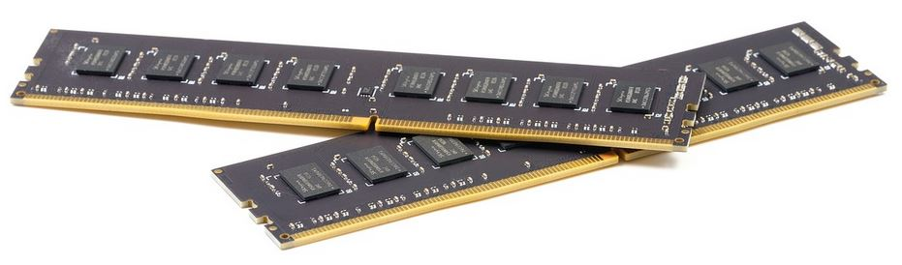
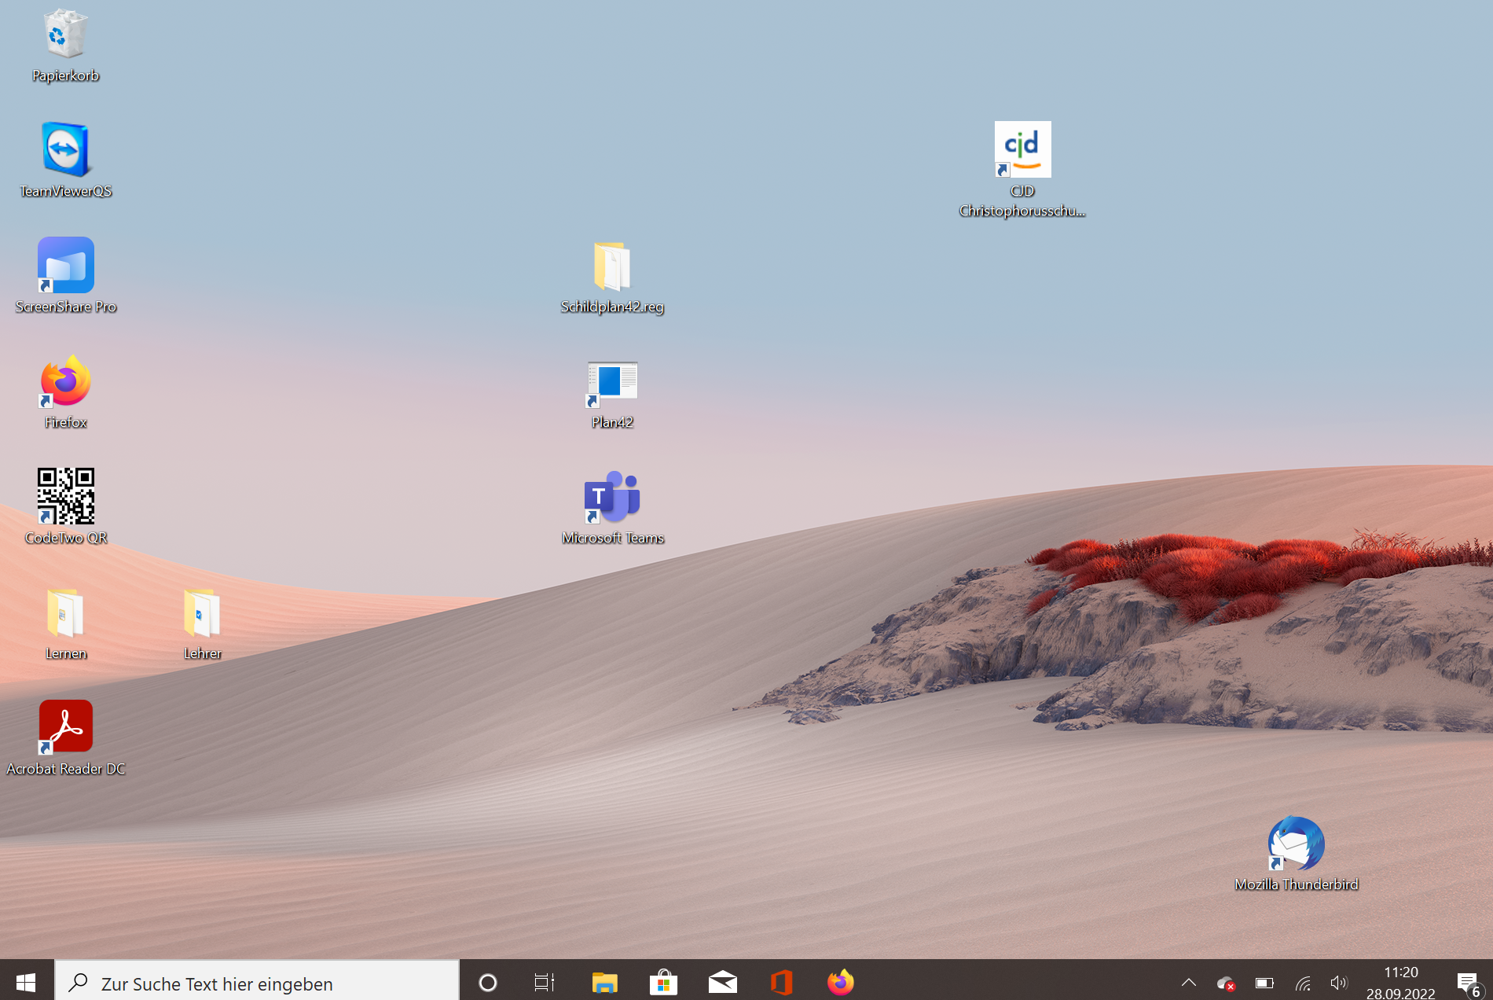
____________________________________________________
____________________________________________________
____________________________________________________
____________________________________________________
____________________________________________________

Festplatte


