Offene Aufgabe
„Jugendarbeitsschutz“

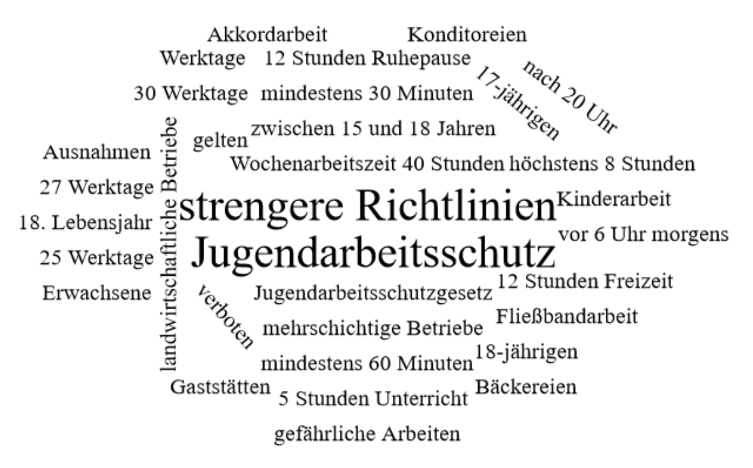

Bitte erstellen Sie anhand der Wortwolke einen Text über den Inhaltsbereich „Jugendarbeitsschutz“.
___________________________________________________________________________
____________________________________________________________________________
_________________________________________________________________________
____________________________________________________________________________
____________________________________________________________________________
____________________________________________________________________________
____________________________________________________________________________
____________________________________________________________________________
____________________________________________________________________________
____________________________________________________________________________
____________________________________________________________________________
____________________________________________________________________________
____________________________________________________________________________
____________________________________________________________________________
____________________________________________________________________________
____________________________________________________________________________
____________________________________________________________________________
____________________________________________________________________________
____________________________________________________________________________
____________________________________________________________________________
________________________________________________________________________________________________________________________________________________________
____________________________________________________________________________
____________________________________________________________________________
____________________________________________________________________________
____________________________________________________________________________
____________________________________________________________________________
____________________________________________________________________________
____________________________________________________________________________
____________________________________________________________________________
____________________________________________________________________________
____________________________________________________________________________
____________________________________________________________________________
____________________________________________________________________________
____________________________________________________________________________
________________________________________________________________________________________________________________________________________________________
____________________________________________________________________________
____________________________________________________________________________
____________________________________________________________________________
____________________________________________________________________________
____________________________________________________________________________
____________________________________________________________________________

