Offene Fragen
„Mutterschutz und Elternzeit“

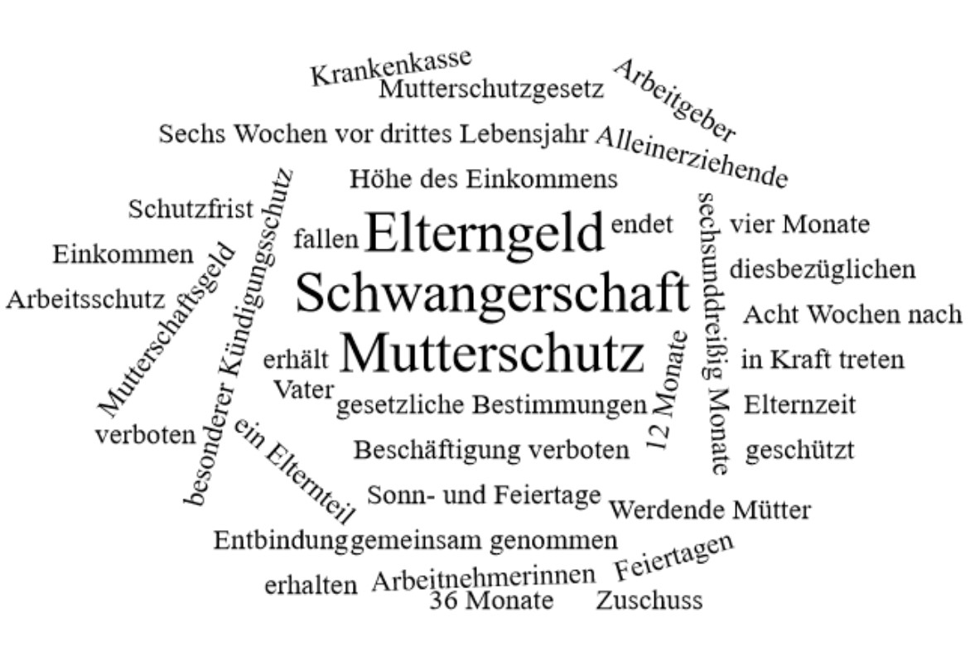
Bitte erstellen Sie anhand der Wortwolke einen Text über die Inhaltsbereiche „Mutterschutz“ und Elternzeit“.
___________________________________________________________________________
____________________________________________________________________________
_________________________________________________________________________
____________________________________________________________________________
____________________________________________________________________________
____________________________________________________________________________
____________________________________________________________________________
____________________________________________________________________________
____________________________________________________________________________
____________________________________________________________________________
____________________________________________________________________________
____________________________________________________________________________
____________________________________________________________________________
____________________________________________________________________________
____________________________________________________________________________
____________________________________________________________________________
____________________________________________________________________________
____________________________________________________________________________
____________________________________________________________________________
____________________________________________________________________________
________________________________________________________________________________________________________________________________________________________
____________________________________________________________________________
____________________________________________________________________________
____________________________________________________________________________

