Offene Aufgabe
„Schwerbehindertenschutz und Bundesurlaubsgesetz“

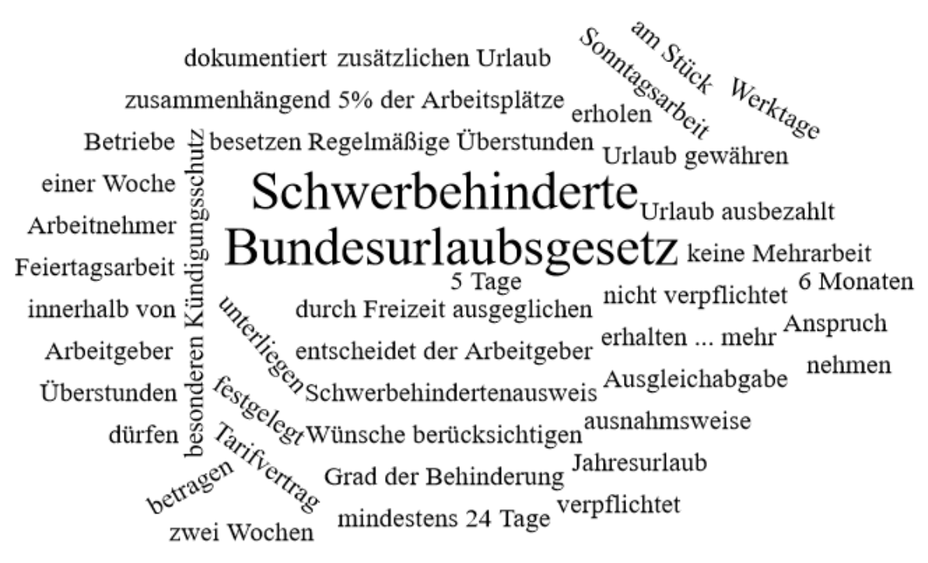

Bitte erstellen Sie anhand der Wortwolke einen Text über die Inhaltsbereiche „Schwerbehindertenschutz und Bundesurlaubsgesetz“.
___________________________________________________________________________
____________________________________________________________________________
_________________________________________________________________________
____________________________________________________________________________
____________________________________________________________________________
____________________________________________________________________________
____________________________________________________________________________
____________________________________________________________________________
____________________________________________________________________________
____________________________________________________________________________
____________________________________________________________________________
____________________________________________________________________________
____________________________________________________________________________
____________________________________________________________________________
____________________________________________________________________________
____________________________________________________________________________
____________________________________________________________________________
____________________________________________________________________________
____________________________________________________________________________
____________________________________________________________________________
________________________________________________________________________________________________________________________________________________________
____________________________________________________________________________
____________________________________________________________________________
____________________________________________________________________________
____________________________________________________________________________
____________________________________________________________________________
____________________________________________________________________________
____________________________________________________________________________
____________________________________________________________________________
____________________________________________________________________________
____________________________________________________________________________
____________________________________________________________________________
____________________________________________________________________________
____________________________________________________________________________
________________________________________________________________________________________________________________________________________________________
____________________________________________________________________________
____________________________________________________________________________
____________________________________________________________________________
____________________________________________________________________________
____________________________________________________________________________
____________________________________________________________________________

