Offene Aufgabe
„Bargeldlose Zahlung“

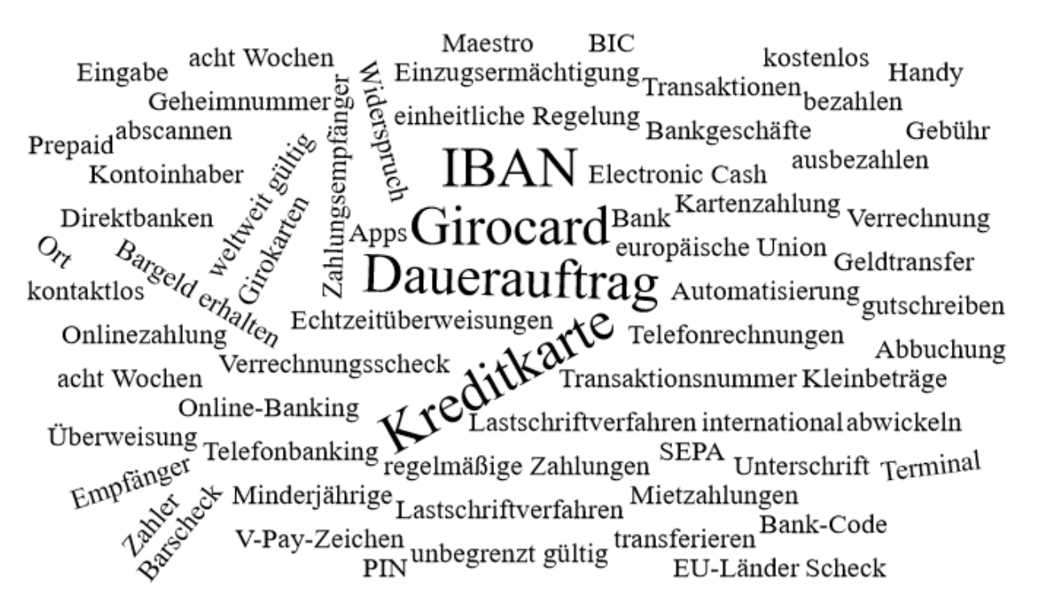

Bitte erstellen Sie anhand der Wortwolke einen Text über den Inhaltsbereich „Bargeldlose Zahlung“.
___________________________________________________________________________
____________________________________________________________________________
_________________________________________________________________________
____________________________________________________________________________
____________________________________________________________________________
____________________________________________________________________________
____________________________________________________________________________
____________________________________________________________________________
____________________________________________________________________________
____________________________________________________________________________
____________________________________________________________________________
____________________________________________________________________________
____________________________________________________________________________
____________________________________________________________________________
____________________________________________________________________________
____________________________________________________________________________
____________________________________________________________________________
____________________________________________________________________________
____________________________________________________________________________
____________________________________________________________________________
________________________________________________________________________________________________________________________________________________________
____________________________________________________________________________
____________________________________________________________________________
________________________________________________________________________________________________________________________________________________________
____________________________________________________________________________
____________________________________________________________________________
____________________________________________________________________________
____________________________________________________________________________
____________________________________________________________________________
____________________________________________________________________________
____________________________________________________________________________
____________________________________________________________________________
____________________________________________________________________________
________________________________________________________________________________________________________________________________________________________
____________________________________________________________________________
____________________________________________________________________________
____________________________________________________________________________
____________________________________________________________________________
____________________________________________________________________________________________________________________________________________________________________________________________________________________________________
____________________________________________________________________________
_______________________________________________________________________________________________________________________________________________________
____________________________________________________________________________
_________________________________________________________________________
____________________________________________________________________________
____________________________________________________________________________
____________________________________________________________________________
____________________________________________________________________________
____________________________________________________________________________
____________________________________________________________________________
____________________________________________________________________________
____________________________________________________________________________
____________________________________________________________________________
____________________________________________________________________________
___________________________________________________________________________
____________________________________________________________________________
_________________________________________________________________________
____________________________________________________________________________
____________________________________________________________________________
____________________________________________________________________________
____________________________________________________________________________
____________________________________________________________________________
____________________________________________________________________________
____________________________________________________________________________
____________________________________________________________________________
____________________________________________________________________________
____________________________________________________________________________
___________________________________________________________________________
____________________________________________________________________________
_________________________________________________________________________
____________________________________________________________________________
____________________________________________________________________________
____________________________________________________________________________
____________________________________________________________________________
____________________________________________________________________________

