Offene Aufgabe
„Gerichtliches Mahnverfahren“

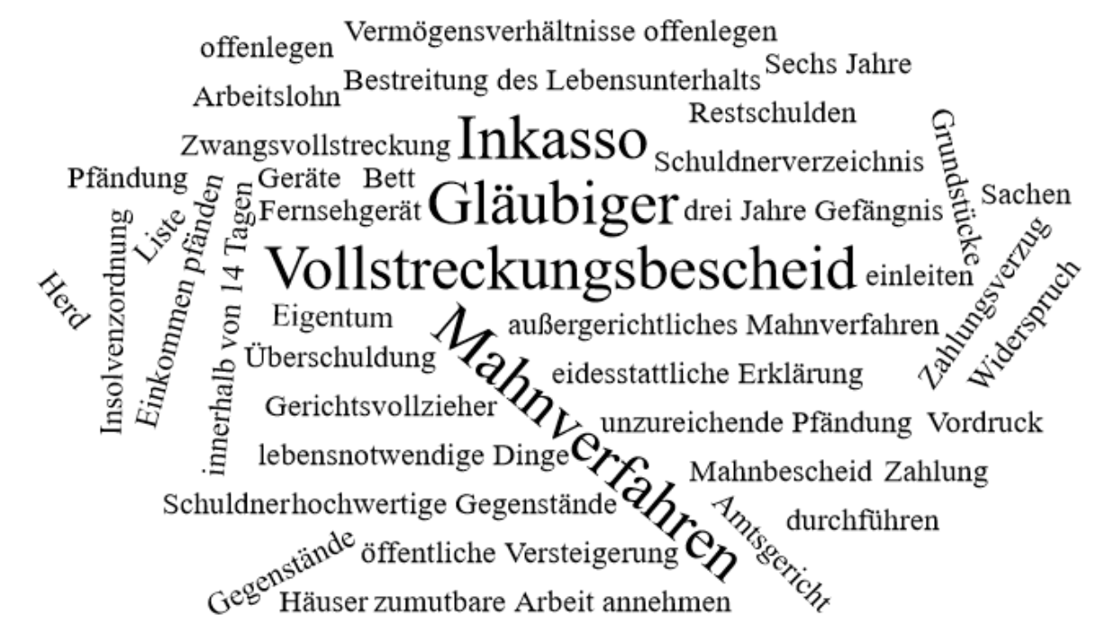

Bitte erstellen Sie anhand der Wortwolke einen Text über den Inhaltsbereich „Gerichtliches Mahnverfahren“.
___________________________________________________________________________
____________________________________________________________________________
_________________________________________________________________________
____________________________________________________________________________
____________________________________________________________________________
____________________________________________________________________________
____________________________________________________________________________
____________________________________________________________________________
____________________________________________________________________________
____________________________________________________________________________
____________________________________________________________________________
____________________________________________________________________________
____________________________________________________________________________
____________________________________________________________________________
____________________________________________________________________________
____________________________________________________________________________
____________________________________________________________________________
____________________________________________________________________________
____________________________________________________________________________
____________________________________________________________________________
________________________________________________________________________________________________________________________________________________________
____________________________________________________________________________
____________________________________________________________________________
________________________________________________________________________________________________________________________________________________________
____________________________________________________________________________
____________________________________________________________________________
____________________________________________________________________________
____________________________________________________________________________
____________________________________________________________________________
____________________________________________________________________________
____________________________________________________________________________
____________________________________________________________________________
____________________________________________________________________________
________________________________________________________________________________________________________________________________________________________
____________________________________________________________________________
____________________________________________________________________________
____________________________________________________________________________
____________________________________________________________________________
____________________________________________________________________________________________________________________________________________________________________________________________________________________________________
____________________________________________________________________________
_______________________________________________________________________________________________________________________________________________________
____________________________________________________________________________
_________________________________________________________________________
____________________________________________________________________________
____________________________________________________________________________
____________________________________________________________________________
____________________________________________________________________________
____________________________________________________________________________
____________________________________________________________________________
____________________________________________________________________________
____________________________________________________________________________
____________________________________________________________________________
____________________________________________________________________________
___________________________________________________________________________
____________________________________________________________________________
_________________________________________________________________________
____________________________________________________________________________
____________________________________________________________________________
____________________________________________________________________________
____________________________________________________________________________
____________________________________________________________________________
____________________________________________________________________________
____________________________________________________________________________
____________________________________________________________________________
____________________________________________________________________________
____________________________________________________________________________
___________________________________________________________________________
____________________________________________________________________________
_________________________________________________________________________
____________________________________________________________________________
____________________________________________________________________________
____________________________________________________________________________
____________________________________________________________________________
____________________________________________________________________________

