Offene Aufgabe
„Innerbetriebliche Mitbestimmung: Betriebsrat“

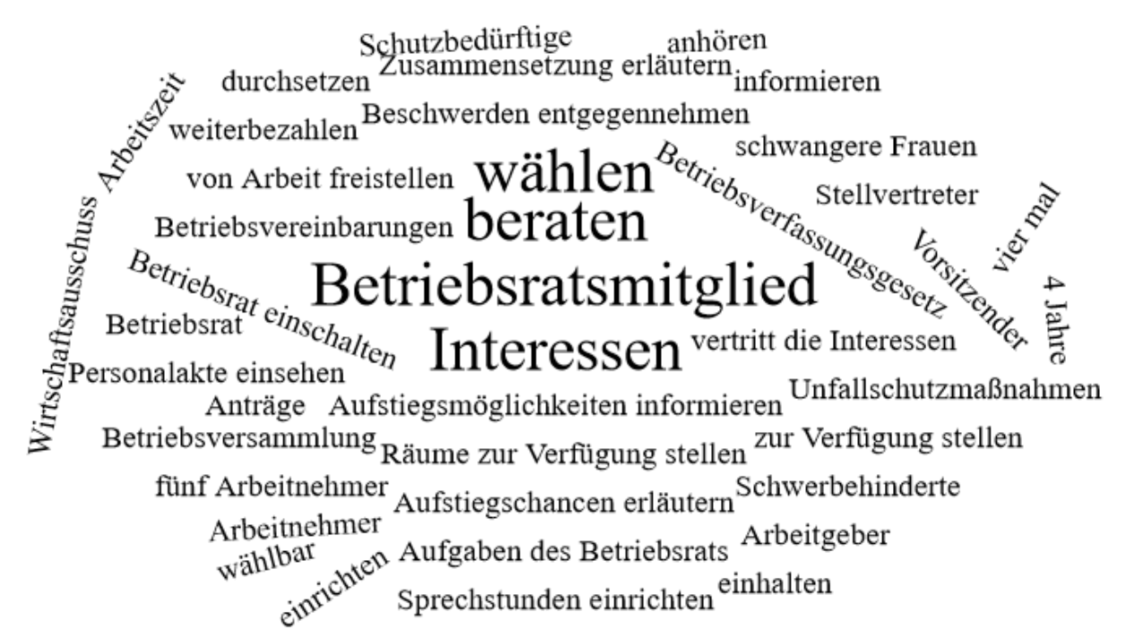

Bitte erstellen Sie anhand der Wortwolke einen Text über den Inhaltsbereich „Innerbetriebliche Mitbestimmung - Betriebsrat“.
___________________________________________________________________________
____________________________________________________________________________
_________________________________________________________________________
____________________________________________________________________________
____________________________________________________________________________
____________________________________________________________________________
____________________________________________________________________________
____________________________________________________________________________
____________________________________________________________________________
____________________________________________________________________________
____________________________________________________________________________
____________________________________________________________________________
____________________________________________________________________________
____________________________________________________________________________
____________________________________________________________________________
____________________________________________________________________________
____________________________________________________________________________
____________________________________________________________________________
____________________________________________________________________________
____________________________________________________________________________
________________________________________________________________________________________________________________________________________________________
____________________________________________________________________________
____________________________________________________________________________
________________________________________________________________________________________________________________________________________________________
____________________________________________________________________________
____________________________________________________________________________
____________________________________________________________________________
____________________________________________________________________________
____________________________________________________________________________
____________________________________________________________________________
____________________________________________________________________________
____________________________________________________________________________
____________________________________________________________________________
________________________________________________________________________________________________________________________________________________________
____________________________________________________________________________
____________________________________________________________________________
____________________________________________________________________________
____________________________________________________________________________
____________________________________________________________________________________________________________________________________________________________________________________________________________________________________
____________________________________________________________________________
____________________________________________________________________________
____________________________________________________________________________
____________________________________________________________________________

