Offene Fragen
„Wettbewerbsstörungen“
1. Was ist ein Kartell?
_______________________________
_______________________________
_______________________________
_______________________________
_______________________________
_______________________________
_______________________________
_______________________________
_______________________________
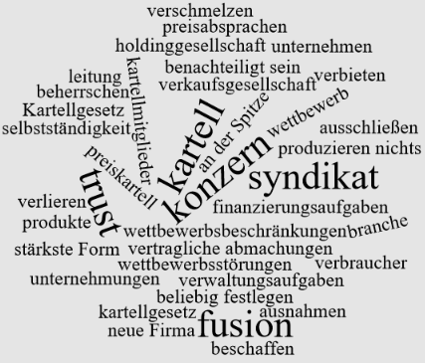
2. Warum sind Kartelle in der Regel verboten?
___________________________________________________________________________
___________________________________________________________________________
______________________________________________________________________________________________________________________________________________________
3. Was kennzeichnet ein Syndikat?
___________________________________________________________________________
___________________________________________________________________________
___________________________________________________________________________
4. Was ist ein Konzern?
___________________________________________________________________________
___________________________________________________________________________
___________________________________________________________________________
___________________________________________________________________________
___________________________________________________________________________
___________________________________________________________________________
5. Was ist eine Holdinggesellschaft?
___________________________________________________________________________
___________________________________________________________________________
___________________________________________________________________________
___________________________________________________________________________
___________________________________________________________________________
___________________________________________________________________________
6. Erklären Sie bitte die Begriffe „Trust“ und „Fusion“.
___________________________________________________________________________
___________________________________________________________________________
___________________________________________________________________________
___________________________________________________________________________
___________________________________________________________________________
___________________________________________________________________________
7. Nennen Sie bitte jeweils ein Beispiel für die Organisationsformen „Kartell“, „Konzern“ und „Trust“.
___________________________________________________________________________
___________________________________________________________________________
___________________________________________________________________________
___________________________________________________________________________
___________________________________________________________________________
___________________________________________________________________________

