Offene Aufgabe
„Sozialversicherungen: Gesetzliche Rentenversicherung“

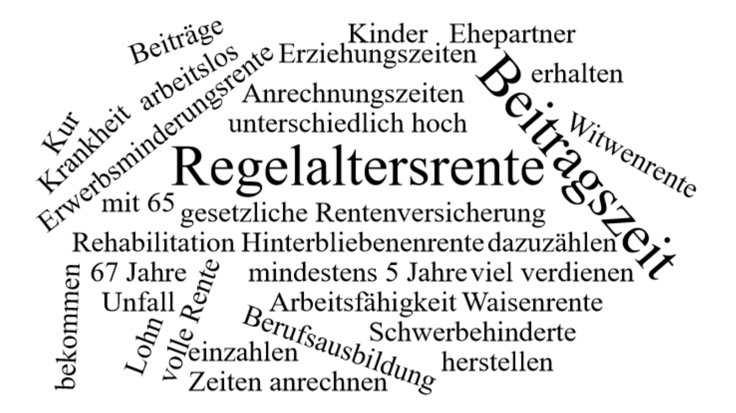

Bitte erstellen Sie anhand der Wortwolke einen Text über den Inhaltsbereich „Gesetzliche Rentenversicherung“.
___________________________________________________________________________
____________________________________________________________________________
_________________________________________________________________________
____________________________________________________________________________
____________________________________________________________________________
____________________________________________________________________________
____________________________________________________________________________
____________________________________________________________________________
____________________________________________________________________________
____________________________________________________________________________
____________________________________________________________________________
____________________________________________________________________________
____________________________________________________________________________
____________________________________________________________________________
____________________________________________________________________________
____________________________________________________________________________
____________________________________________________________________________
____________________________________________________________________________
____________________________________________________________________________
____________________________________________________________________________
________________________________________________________________________________________________________________________________________________________
____________________________________________________________________________
____________________________________________________________________________
________________________________________________________________________________________________________________________________________________________
____________________________________________________________________________
____________________________________________________________________________
____________________________________________________________________________
____________________________________________________________________________
____________________________________________________________________________
____________________________________________________________________________
____________________________________________________________________________
____________________________________________________________________________
____________________________________________________________________________
________________________________________________________________________________________________________________________________________________________
____________________________________________________________________________
____________________________________________________________________________
____________________________________________________________________________
____________________________________________________________________________
____________________________________________________________________________________________________________________________________________________________________________________________________________________________________
____________________________________________________________________________
____________________________________________________________________________
____________________________________________________________________________
____________________________________________________________________________

