Name: ____________________________________ Klasse: __________ Datum: __________
Bitte beantworten sie mit Hilfe der Wortwolke die nachfolgenden Fragen.

Offene Fragen
„Tarifverhandlungen – Streik und Streikarten“
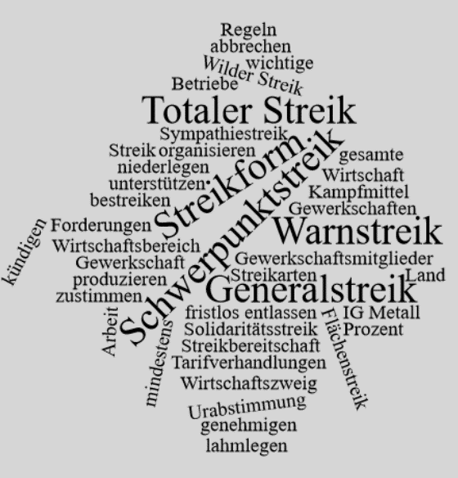

1. Was ist ein Streik und was soll er bewirken?.
_________________________________________________________________
_________________________________________________________________
_________________________________________________________________
_________________________________________________________________
2. Unter welchen Voraussetzungen kann ein Streik stattfinden und wieder beendet werden?
_________________________________________________________________
_________________________________________________________________
_________________________________________________________________
_________________________________________________________________
3. Was versteht man unter einem „Wilden Streik“ und welche Konsequenzen kann die Durchführung eines solchen Streiks für die Streikenden mit sich bringen?
_________________________________________________________________
_________________________________________________________________
_________________________________________________________________
_________________________________________________________________
4. Nennen und erläutern Sie die verschiedenen Streikarten.
_________________________________________________________________
_________________________________________________________________
_________________________________________________________________
_________________________________________________________________
_________________________________________________________________
_________________________________________________________________
_________________________________________________________________
_________________________________________________________________
_________________________________________________________________
_________________________________________________________________
_________________________________________________________________
_________________________________________________________________
_________________________________________________________________
_________________________________________________________________
_________________________________________________________________
_________________________________________________________________
_________________________________________________________________
_________________________________________________________________
_________________________________________________________________
_________________________________________________________________
_________________________________________________________________
_________________________________________________________________
_________________________________________________________________
_________________________________________________________________
_________________________________________________________________
_________________________________________________________________
_________________________________________________________________
_________________________________________________________________
_________________________________________________________________
_________________________________________________________________
_________________________________________________________________
_________________________________________________________________
_________________________________________________________________
_________________________________________________________________

