Offene Fragen (Fachpraktiker*innen)
„Tarifverhandlungen – Tarifvertragsarten und Ablauf von Tarifverhandlungen“

Bitte beantworten Sie anhand der Wortwolke die nachfolgenden Fragen:
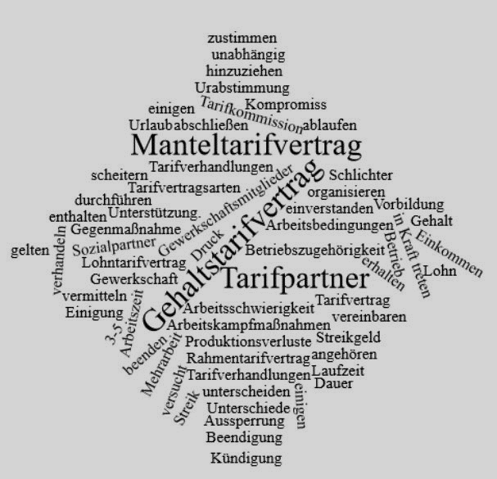

- Welche beiden Tarifvertragsformen unterscheidet man?
____________________________________________________________________________
____________________________________________________________________________
- Welche Regelungen enthalten die beiden Tarifvertragsformen?
____________________________________________________________________________
____________________________________________________________________________
________________________________________________________________________________________________________________________________________________________
____________________________________________________________________________
____________________________________________________________________________
____________________________________________________________________________
- Was ist eine Tarifkommission?
____________________________________________________________________________
____________________________________________________________________________
____________________________________________________________________________
____________________________________________________________________________
____________________________________________________________________________
- Beschreiben Sie den Verlauf der Tarifverhandlungen. Folgende Stichwörter sollen in der Beschreibung vorkommen:
Schlichtung / neue Verhandlungen / Streik / Aussperrung / Einkommens- und Produktionsverluste / Kompromiss / Tarifkommission / Urabstimmung
____________________________________________________________________________
____________________________________________________________________________
____________________________________________________________________________
____________________________________________________________________________
____________________________________________________________________________
____________________________________________________________________________
____________________________________________________________________________
____________________________________________________________________________
____________________________________________________________________________
____________________________________________________________________________
____________________________________________________________________________
____________________________________________________________________________
____________________________________________________________________________
____________________________________________________________________________
____________________________________________________________________________
____________________________________________________________________________
____________________________________________________________________________
____________________________________________________________________________
____________________________________________________________________________
____________________________________________________________________________
____________________________________________________________________________
____________________________________________________________________________
____________________________________________________________________________
____________________________________________________________________________
____________________________________________________________________________
____________________________________________________________________________
____________________________________________________________________________
____________________________________________________________________________
____________________________________________________________________________
____________________________________________________________________________
____________________________________________________________________________
____________________________________________________________________________
____________________________________________________________________________
____________________________________________________________________________
____________________________________________________________________________
____________________________________________________________________________
____________________________________________________________________________

