Offene Aufgabe
„Besitz und Eigentum“

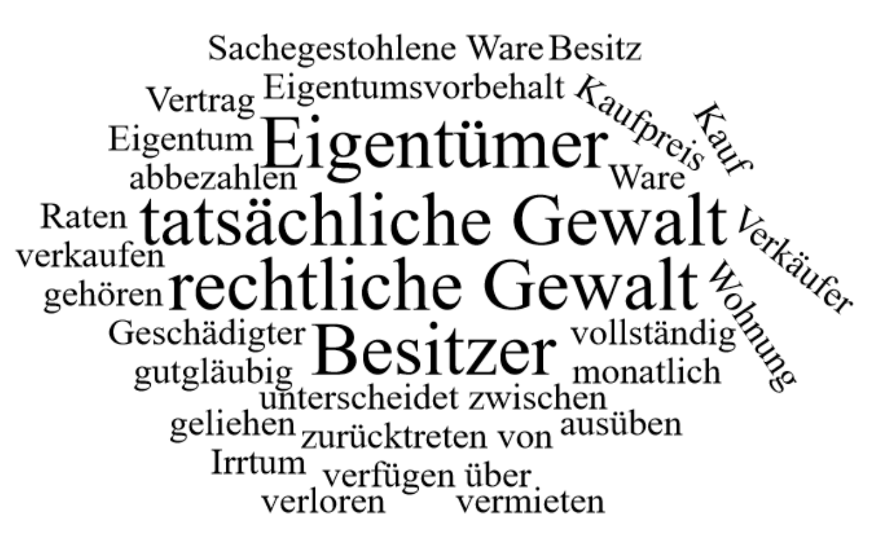

Bitte erstellen Sie anhand der Wortwolke einen Text über den Inhaltsbereich „Besitz und Eigentum“.
___________________________________________________________________________
____________________________________________________________________________
_________________________________________________________________________
____________________________________________________________________________
____________________________________________________________________________
____________________________________________________________________________
____________________________________________________________________________
____________________________________________________________________________
____________________________________________________________________________
____________________________________________________________________________
____________________________________________________________________________
____________________________________________________________________________
____________________________________________________________________________
____________________________________________________________________________
____________________________________________________________________________
____________________________________________________________________________
____________________________________________________________________________
____________________________________________________________________________
____________________________________________________________________________
____________________________________________________________________________
________________________________________________________________________________________________________________________________________________________
____________________________________________________________________________
____________________________________________________________________________
________________________________________________________________________________________________________________________________________________________
____________________________________________________________________________
____________________________________________________________________________
____________________________________________________________________________
____________________________________________________________________________
____________________________________________________________________________
____________________________________________________________________________
____________________________________________________________________________
____________________________________________________________________________
____________________________________________________________________________
________________________________________________________________________________________________________________________________________________________
____________________________________________________________________________
____________________________________________________________________________
____________________________________________________________________________
____________________________________________________________________________
________________________________________________________________________________________________________________________________________________________
____________________________________________________________________________
____________________________________________________________________________
____________________________________________________________________________
____________________________________________________________________________
____________________________________________________________________________

