Offene Aufgabe
„Pflichtverletzungen – Mangelhafte Lieferung“

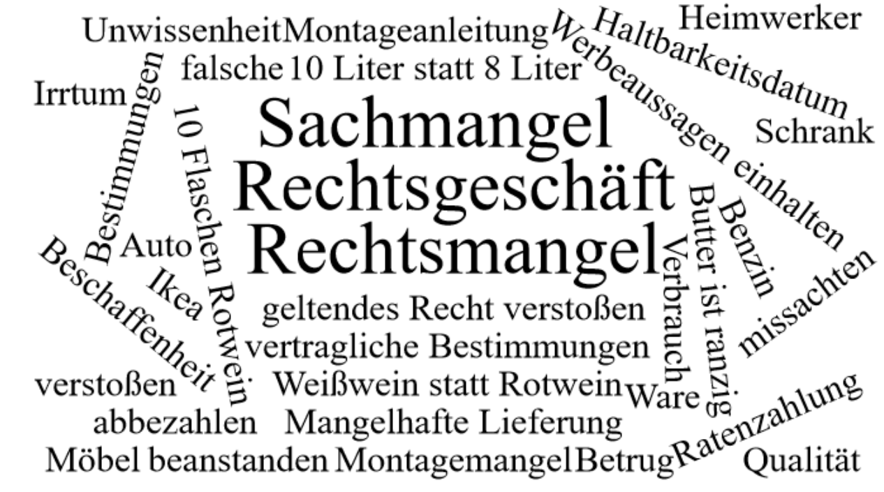

Bitte erstellen Sie anhand der Wortwolke einen Text über den Inhaltsbereich „Pflichtverletzungen – Mangelhafte Lieferung“.
___________________________________________________________________________
____________________________________________________________________________
_________________________________________________________________________
____________________________________________________________________________
____________________________________________________________________________
____________________________________________________________________________
____________________________________________________________________________
____________________________________________________________________________
____________________________________________________________________________
____________________________________________________________________________
____________________________________________________________________________
____________________________________________________________________________
____________________________________________________________________________
____________________________________________________________________________
____________________________________________________________________________
____________________________________________________________________________
____________________________________________________________________________
____________________________________________________________________________
____________________________________________________________________________
____________________________________________________________________________
________________________________________________________________________________________________________________________________________________________
____________________________________________________________________________
____________________________________________________________________________
________________________________________________________________________________________________________________________________________________________
____________________________________________________________________________
____________________________________________________________________________
____________________________________________________________________________
____________________________________________________________________________
____________________________________________________________________________
____________________________________________________________________________
____________________________________________________________________________
____________________________________________________________________________
____________________________________________________________________________
________________________________________________________________________________________________________________________________________________________
____________________________________________________________________________
____________________________________________________________________________
____________________________________________________________________________
____________________________________________________________________________
________________________________________________________________________________________________________________________________________________________
____________________________________________________________________________
____________________________________________________________________________
____________________________________________________________________________
____________________________________________________________________________
____________________________________________________________________________

