Offene Aufgabe
„Pflichtverletzungen – Rechte des Käufers“

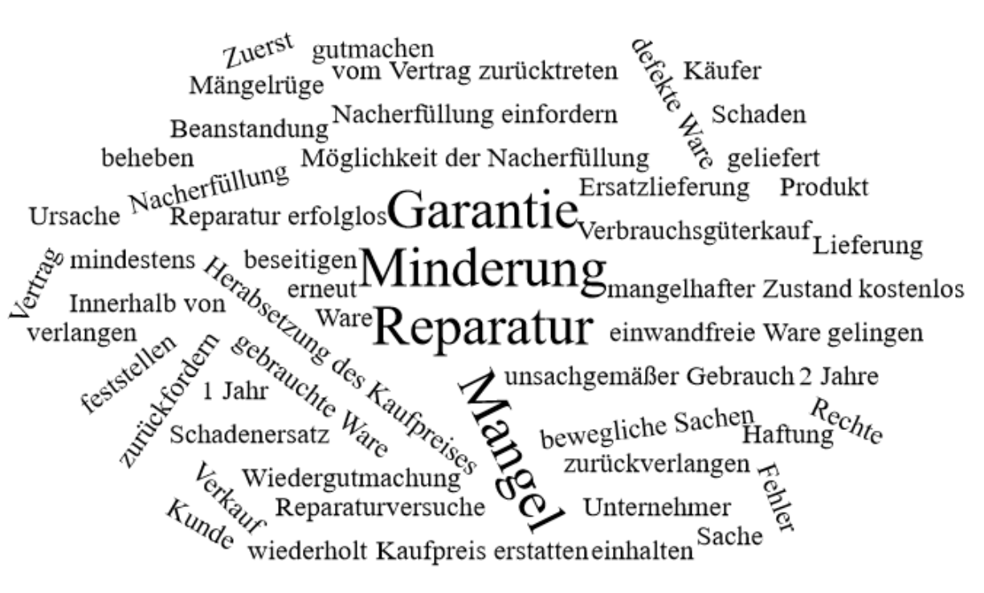

Bitte erstellen Sie anhand der Wortwolke einen Text über den Inhaltsbereich „Pflichtverletzungen – Rechte des Käufers“.
___________________________________________________________________________
____________________________________________________________________________
_________________________________________________________________________
____________________________________________________________________________
____________________________________________________________________________
____________________________________________________________________________
____________________________________________________________________________
____________________________________________________________________________
____________________________________________________________________________
____________________________________________________________________________
____________________________________________________________________________
____________________________________________________________________________
____________________________________________________________________________
____________________________________________________________________________
____________________________________________________________________________
____________________________________________________________________________
____________________________________________________________________________
____________________________________________________________________________
____________________________________________________________________________
____________________________________________________________________________
________________________________________________________________________________________________________________________________________________________
____________________________________________________________________________
____________________________________________________________________________
________________________________________________________________________________________________________________________________________________________
____________________________________________________________________________
____________________________________________________________________________
____________________________________________________________________________
____________________________________________________________________________
____________________________________________________________________________
____________________________________________________________________________
____________________________________________________________________________
____________________________________________________________________________
____________________________________________________________________________
________________________________________________________________________________________________________________________________________________________
____________________________________________________________________________
____________________________________________________________________________
____________________________________________________________________________
____________________________________________________________________________
________________________________________________________________________________________________________________________________________________________
____________________________________________________________________________
____________________________________________________________________________
____________________________________________________________________________
____________________________________________________________________________
____________________________________________________________________________

