Offene Aufgabe
„Rechtsfähigkeit“

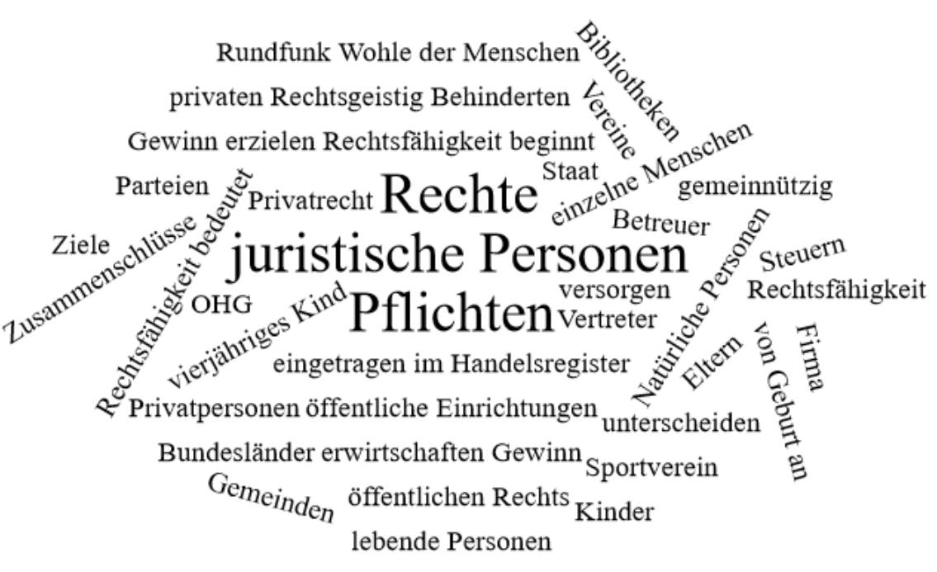

Bitte erstellen Sie anhand der Wortwolke einen Text über die Inhaltsbereiche „Rechtsfähigkeit“.
___________________________________________________________________________
____________________________________________________________________________
_________________________________________________________________________
____________________________________________________________________________
____________________________________________________________________________
____________________________________________________________________________
____________________________________________________________________________
____________________________________________________________________________
____________________________________________________________________________
____________________________________________________________________________
____________________________________________________________________________
____________________________________________________________________________
____________________________________________________________________________
____________________________________________________________________________
____________________________________________________________________________
____________________________________________________________________________
____________________________________________________________________________
____________________________________________________________________________
____________________________________________________________________________
____________________________________________________________________________
________________________________________________________________________________________________________________________________________________________
____________________________________________________________________________
____________________________________________________________________________
________________________________________________________________________________________________________________________________________________________
____________________________________________________________________________
____________________________________________________________________________
____________________________________________________________________________
____________________________________________________________________________
____________________________________________________________________________
____________________________________________________________________________
____________________________________________________________________________
____________________________________________________________________________
____________________________________________________________________________
________________________________________________________________________________________________________________________________________________________
____________________________________________________________________________
____________________________________________________________________________
____________________________________________________________________________
____________________________________________________________________________
____________________________________________________________________________

