Offene Aufgabe
„Formvorschriften“

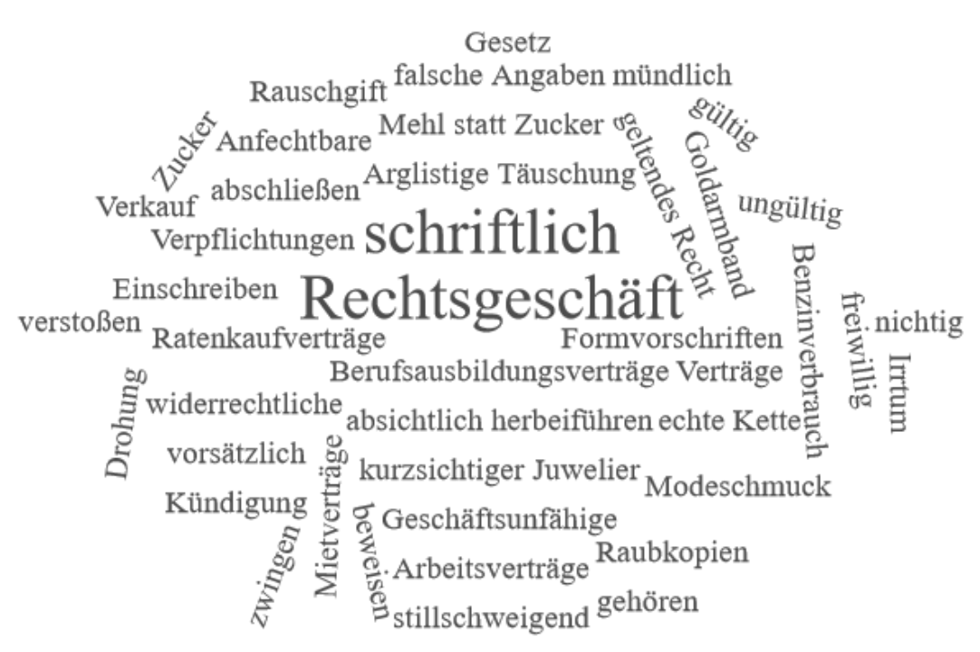

Bitte erstellen Sie anhand der Wortwolke einen Text über die Inhaltsbereiche „Formvorschriften“.
___________________________________________________________________________
____________________________________________________________________________
_________________________________________________________________________
____________________________________________________________________________
____________________________________________________________________________
____________________________________________________________________________
____________________________________________________________________________
____________________________________________________________________________
____________________________________________________________________________
____________________________________________________________________________
____________________________________________________________________________
____________________________________________________________________________
____________________________________________________________________________
____________________________________________________________________________
____________________________________________________________________________
____________________________________________________________________________
____________________________________________________________________________
____________________________________________________________________________
____________________________________________________________________________
____________________________________________________________________________
________________________________________________________________________________________________________________________________________________________
____________________________________________________________________________
____________________________________________________________________________
________________________________________________________________________________________________________________________________________________________
____________________________________________________________________________
____________________________________________________________________________
____________________________________________________________________________
____________________________________________________________________________
____________________________________________________________________________
____________________________________________________________________________
____________________________________________________________________________
____________________________________________________________________________
____________________________________________________________________________
________________________________________________________________________________________________________________________________________________________
____________________________________________________________________________
____________________________________________________________________________
____________________________________________________________________________
____________________________________________________________________________
____________________________________________________________________________

