Offene Aufgabe
„Rechtsgeschäfte“

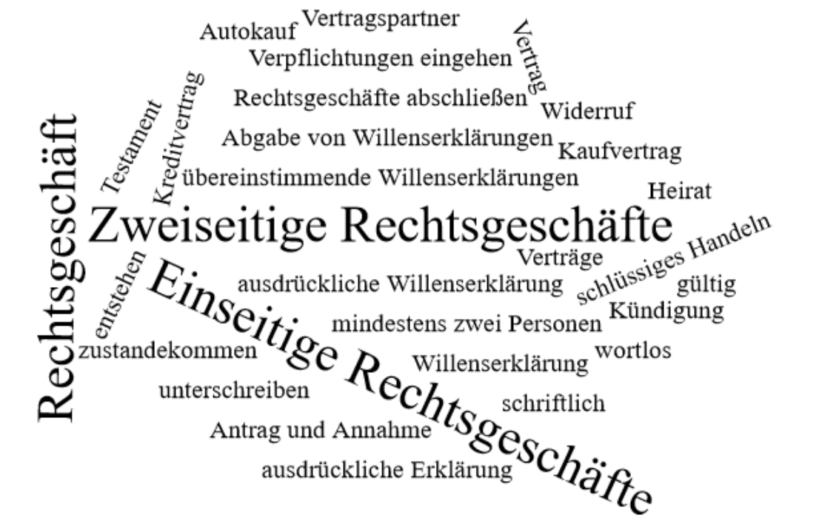

Bitte erstellen Sie anhand der Wortwolke einen Text über die Inhaltsbereiche „Rechtsgeschäfte“.
___________________________________________________________________________
____________________________________________________________________________
_________________________________________________________________________
____________________________________________________________________________
____________________________________________________________________________
____________________________________________________________________________
____________________________________________________________________________
____________________________________________________________________________
____________________________________________________________________________
____________________________________________________________________________
____________________________________________________________________________
____________________________________________________________________________
____________________________________________________________________________
____________________________________________________________________________
____________________________________________________________________________
____________________________________________________________________________
____________________________________________________________________________
____________________________________________________________________________
____________________________________________________________________________
____________________________________________________________________________
________________________________________________________________________________________________________________________________________________________
____________________________________________________________________________
____________________________________________________________________________
________________________________________________________________________________________________________________________________________________________
____________________________________________________________________________
____________________________________________________________________________
____________________________________________________________________________
____________________________________________________________________________
____________________________________________________________________________
____________________________________________________________________________
____________________________________________________________________________
____________________________________________________________________________
____________________________________________________________________________
________________________________________________________________________________________________________________________________________________________
____________________________________________________________________________
____________________________________________________________________________
____________________________________________________________________________
____________________________________________________________________________
________________________________________________________________________________________________________________________________________________________
________________________________________________________________________________________________________________________________________________________
____________________________________________________________________________
____________________________________________________________________________
____________________________________________________________________________
____________________________________________________________________________
____________________________________________________________________________

