Offene Aufgabe
„Weitere wichtige Verträge“

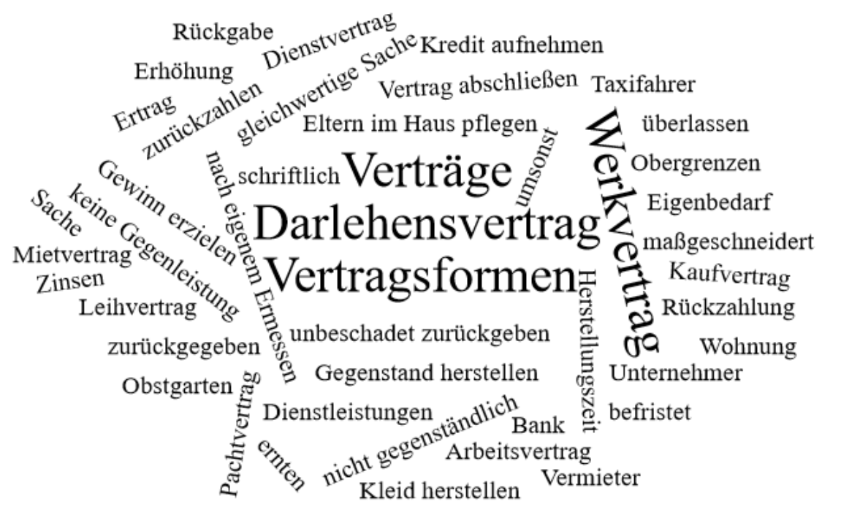

Bitte erstellen Sie anhand der Wortwolke einen Text über den Inhaltsbereich „Weitere wichtige Verträge“.
___________________________________________________________________________
____________________________________________________________________________
_________________________________________________________________________
____________________________________________________________________________
____________________________________________________________________________
____________________________________________________________________________
____________________________________________________________________________
____________________________________________________________________________
____________________________________________________________________________
____________________________________________________________________________
____________________________________________________________________________
____________________________________________________________________________
____________________________________________________________________________
____________________________________________________________________________
____________________________________________________________________________
____________________________________________________________________________
____________________________________________________________________________
____________________________________________________________________________
____________________________________________________________________________
____________________________________________________________________________
________________________________________________________________________________________________________________________________________________________
____________________________________________________________________________
____________________________________________________________________________
________________________________________________________________________________________________________________________________________________________
____________________________________________________________________________
____________________________________________________________________________
____________________________________________________________________________
____________________________________________________________________________
____________________________________________________________________________
____________________________________________________________________________
____________________________________________________________________________
____________________________________________________________________________
____________________________________________________________________________
________________________________________________________________________________________________________________________________________________________
____________________________________________________________________________
____________________________________________________________________________
____________________________________________________________________________
____________________________________________________________________________
____________________________________________________________________________

